**INVENTION DISCLOSURE FORM**

1. **Particulars of Inventors (Faculties/Students)**

|  |  |  |  |  |  |  |
| --- | --- | --- | --- | --- | --- | --- |
| Mr./Ms/Dr. | Name (Full) | Department | Designation | Mobile No. | Email | Postal Address |
| Mr | Ishaan Jain | BTECH CSE | Student | 8920800490 | 06117702722_cse@vips.edu | W-block Green Park Main New Delhi -110016 |
| Mr | Rishab Negi | BTECH CSE | Student | 07817702722 | [07817702722_cse@vips.edu](mailto:07817702722_cse@vips.edu) | Bhikaji Cama Place, Delhi - 110066 |
| Mr | Tarun | BTECH CSE | Student | 07017702722 | 07017702722_cse@vips.edu | Narela  North Delhi  Delhi - 110040 |

1. **Provide a brief descriptive title of the invention:**

Therapique – A Full-Stack Digital Mental Health Appointment & Management Platform

1. **In 100 words or less, please provide an abstract or summary of the invention:**

Therapique is a comprehensive digital platform connecting patients with verified mental health professionals through secure appointment booking, payments, and therapy management. It provides dedicated portals for patients, doctors, and administrators with features like therapist search by specialization, appointment scheduling, payment integration, and patient-doctor communication. Built using the MERN stack (MongoDB, Express, React, Node.js) with integrations like Razorpay/Stripe and Cloudinary, it ensures accessibility, transparency, and data security. The invention addresses the growing need for accessible, stigma-free mental health support.

1. **Detail description of the invention:( Answer to all below are required in detail)**
   1. **Problem the invention is solving**

Mental health services often lack accessibility, transparency, and streamlined management. Patients struggle to find verified professionals, book appointments easily, and maintain privacy. Therapists face inefficiencies in managing schedules and payments.

* 1. **General Utility/application of the invention**
     1. Patients: Easy therapist discovery, booking, payments, and session management.
     2. Therapists: Manage profiles, schedules, earnings, and patient history.
     3. Admin: Verify doctors, monitor appointments, generate analytics.
  2. **Advantages of the invention disclosing about the increased efficiency/efficacy** 
     1. Secure, centralized platform for mental health services.
     2. Eliminates fraud through verified therapist onboarding.
     3. Multi-role access improves efficiency for patients, doctors, and administrators.
     4. Integrated payments streamline transactions.
  3. **Best way of using the invention as well as possible variants** 
     1. Web-based platform (current build).
     2. Possible variants: Mobile app, integration with AI-based therapy chatbots, video consultation, IoT-enabled mental health monitoring devices.
  4. **Working of invention along with Drawing, schematics and flow diagrams if required with complete explanations**
     1. **Patient Flow:** Register → Browse therapists → Book appointment → Pay → Attend session → View history.
     2. **Doctor Flow:** Register/Verification → Manage profile → Accept/Reject appointments → Track earnings.
     3. **Admin Flow:** Verify doctors → Monitor appointments → Generate analytics.

1. **Have you conducted Primary Patent Search? Yes / No (if yes, attach the patent search report)**

No

1. **Existing state-of-the-art and prior arts: (Brief background of the existing knowledge/product/process in the market)**

Platforms like Practo, 1mg, and Lybrate exist but are generalized healthcare systems, not specialized for mental health therapy workflows. They lack deep specialization categorization, comprehensive admin verification, and user-friendly multi-role dashboards.

1. **List out the known ways about how others have tried to solve the same or similar problems? Indicate the disadvantages of these approaches. In addition, please identify any prior art documentation or other material that explains or provides examples of such prior art efforts.**

|  |  |  |  |
| --- | --- | --- | --- |
| S. No. | Existing state of art | Drawbacks in existing state of art | Overcome (how your invention is overcoming the drawback) |
| 1 | Practo | General healthcare focus, not mental health-specific | Specialized therapist categories & mental health-centric design |
| 2 | 1mg | Focused on medicines/diagnostics, limited therapy booking | End-to-end therapy management with booking, payments, follow-ups |
| 3 | Lybrate | Limited admin verification, risks of unverified professionals | Admin panel ensures verified therapists only |
| 4 | Simple Appointment Apps | Lack multi-role dashboards (doctor, admin) | Integrated dashboards for all stakeholders |

1. **List the Technical features and Elements of the invention along with the Description of your invention from start to end.**
   1. **Frontend:** React.js, Vite, Tailwind CSS, Axios, Toastify
   2. **Backend:** Node.js, Express.js, MongoDB, JWT authentication, bcrypt encryption
   3. **Payments:** Razorpay & Stripe integration
   4. **Cloud:** Cloudinary for media storage, MongoDB Atlas for scalable DB hosting
   5. **Architecture:** Three portals (Patient, Doctor, Admin) connected via REST APIs.
2. **List out the features of your invention which are believed to be new and distinguish them over the closest technology.**
   1. Dedicated **multi-role system**: Patient, Doctor, Admin with unique dashboards.
   2. **Verified therapist onboarding** via admin panel.
   3. **Specialized mental health categorization** (CBT, Addiction, Child Therapy, etc.).
   4. Dual **payment integration** (Razorpay + Stripe).
   5. Cloud storage (Cloudinary) for secure therapist/patient data.
3. **Has the invention been built or tested or implemented? If so, please provide the particulars of the first time it was successfully built or implemented (when, where, by whom, and evidence of this event including written or on-line pointers to documentary evidence):All testing details**
   1. **First build:** 2025, developed by Ishaan Jain (Backend), Rishab Negi (Frontend), and Tarun (UI/UX).
   2. **Testing:** Conducted locally on ports 5000 (backend), 5173 (frontend), and 5174 (admin).
   3. **Evidence:** GitHub repository – [Therapique GitHub](https://github.com/RISHAB-999/Therapique).

live website- therapique.vercel.app

* 1. **Outcome:** Successfully implemented booking, payment, and profile management flows.

1. **Briefly state when and how you first conceived this idea?**

First conceived in early 2025 during brainstorming sessions for a project addressing gaps in mental health accessibility. Inspired by the lack of specialized, trustworthy digital platforms for therapy booking.

1. **Have you sold, offered for sale, publicly used or published anything related to this invention? If yes, please briefly explain the dates and circumstances. List those individuals to whom you have revealed your invention. Were non-discloser documents signed prior to discloser in each case? Please state any deadlines of which you may be aware for filing an application on this invention.**
   1. Published on GitHub repository (open-source).
   2. Shared among team members (Ishaan, Rishab, Tarun).
   3. No NDAs signed.
   4. Not yet sold or commercially deployed.
2. **Include any reasons that your invention would not have been obvious to someone of average skill in the art.**
   1. Unlike general telemedicine apps, Therapique integrates **verification-first workflows**, multi-role dashboards, and specialized therapy categorization.
   2. The combination of **secure authentication, payment integration, and mental health–specific specialization** makes it non-obvious to a typical developer.
3. **Additional comments by inventor (if you want to give more details out of scope of this IDF).**
   1. Future scope: AI-driven mental health assistant, mobile app, integration with wearables (stress/heart-rate monitoring).
   2. Potential for scaling across hospitals, NGOs, and private practices.
4. **Drawings/Flowchart/Table**
   1. **System Architecture Diagram** (Frontend ↔ Backend ↔ Database ↔ Cloud/Payment APIs).
   2. **Patient Workflow** (Register → Browse → Book → Pay → Attend → Review).
   3. **Doctor Workflow** (Register → Verify → Manage Schedule → Earnings).
   4. 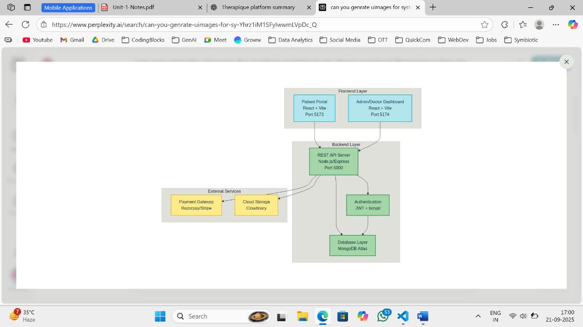**Admin Workflow** (Verify Doctor → Monitor Appointments → Analytics).

System Architecture